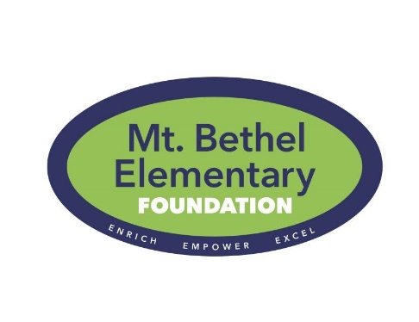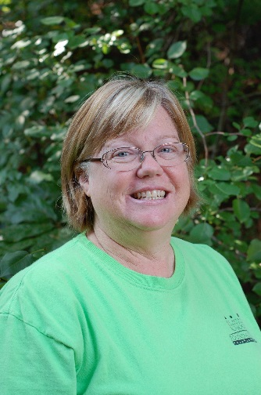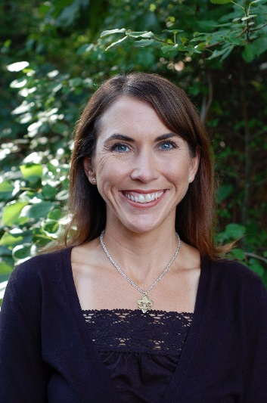

Foundation Newsletter

May 2015

**Dear Mt. Bethel Families,**

Thank you for a successful and productive year! Your monetary donations to the Foundation emphasize the value that our community places on education. We look forward to purposefully serving our school next year and impacting the success of every student at Mt. Bethel!

This year YOUR donations funded:

* 4 full-time employees –
* Reducing class size during specials’ rotation
* Providing hands-on science and technology education for your children
* Online subscriptions
* Enhancing teacher curriculum
* Available to every Mt. Bethel student
* Rugs & Easels in every classroom
* Establishing a productive learning environment
* Assisting teacher lesson plans and strategies
* Columbia University’s nationally recognized *Readers’ Workshop – Lucy Calkins*
* Exclusive training opportunity to solidify instruction across grade levels

Thank you again and have a wonderful summer!

Sarah-Kate & Kathleen

copresidents@mbesf.org

**Summer Shopping?**

For all of your fun-in-the-sun needs remember to shop with AmazonSmile! When you do, Amazon will donate 0.5% of the price of your eligible AmazonSmile purchases to the Mt. Bethel Elementary School Foundation.



[](http://www.facebook.com/MBESF)

Like us on Facebook to keep up all year long!

*School’s out for SUMMER!*

## President’s Note

**On the horizon….**

In our effort to underwrite all operating costs, we are developing a corporate sponsorship program.   This program offers businesses an opportunity to invest in our school and support our mission of enriching education for all Mt. Bethel students.  If you are aware of a business interested in becoming one of our corporate sponsors, please email [sponsors@mbesf.org](mailto:sponsors@mbesf.org) for more information.

Did you know that your student has access to all of the Foundation funded technology over the summer? Your children can continue to practice math with **IXL**, read with **Raz-Kids**, and practice their typing skills with **Type to Learn 4**. They also have access to county provided online materials like the **Online Math Textbook** and the **Cobb Digital Library** (including BrainPop and Pebble Go). You can print worksheets, watch tutorials, and play math games with the online math textbooks. Log-in information is attached to this newsletter!

## **Summer Technology Tidbits**

## From Mrs. Cooper and Mrs. Frey

**SAVE THE DATE!**

**OCTOBER 16th, 2015**

Mrs. Atkins and

Mrs. Wagner are looking forward to your SCIENCE FAIR projects in the fall!

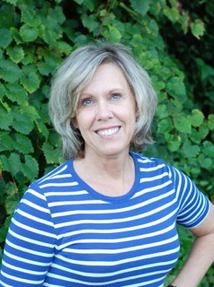 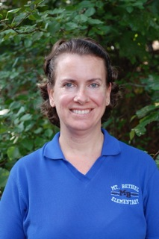

2015 – 2016 FACT Program

Get in gear for our FACT programs next year! We will offer:

* Brainy Builders
* Cardio Cool Kids
* Challenge Island
* Guitar Club
* Impact Performance
* Kid Chess
* Out of this World – Space Program
* Smart Club
* Spanish
* Brainy Bytes (NEW)
* DIY Pinterest Crafts (NEW)

Sign up begins July 27th at www.mbesf.org!